Bukya Anil Kumar

(MTech VLSI Sem 1, EE22M302)

Lab no. : 3

Used version: Matlab 2022

Q.1:- Assume two metal plates A and B are kept at a separation of 100mm in free space.

Plate A is grounded (at x=0) and while plate B is held at a potential of 1V (at x=100

mm). Find the potential profile from Plate A to Plate B. Obtain the results using the

analytical methods as well as numerical methods. Compare the results obtained using

both the methods.

ANS:

Code:

Numerical:

clc;

clear all;

close all;

response =[];

iter = [];

% analytical

% for i=1:100

% v=i/100;

% response = [response v];

% iter = [iter i];

% end

%plot(iter, response);

% numerical

for i=1:100

H(i,i)=-2;

end

for i=1:99

H(i+1,i)=1;

end

for i=1:99

H(i,i+1)=1;

end

A=zeros(100,1);

A(100,1)=-1;

v=(inv(H)*A);

plot (v);

xlabel('distance from plate A');

ylabel(‘potential profile');

title(‘Analytical: potential vs distance');

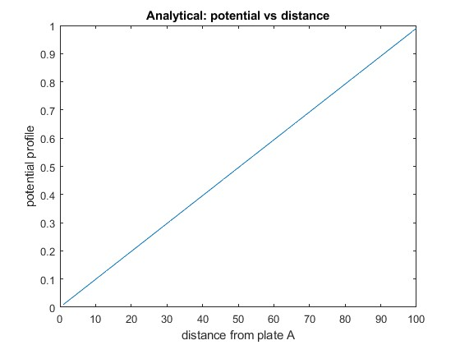

Analytical:

ANS:

Code:

Numerical:

clc;

clear all;

close all;

response =[];

iter = [];

% analytical

% for i=1:100

% v=i/100;

% response = [response v];

% iter = [iter i];

% end

%plot(iter, response);

% numerical

for i=1:100

H(i,i)=-2;

end

for i=1:99

H(i+1,i)=1;

end

for i=1:99

H(i,i+1)=1;

end

A=zeros(100,1);

A(100,1)=-1;

v=(inv(H)*A);

plot (v);

xlabel('distance from plate A');

ylabel(‘potential profile');

title(‘numerical: potential vs distance');

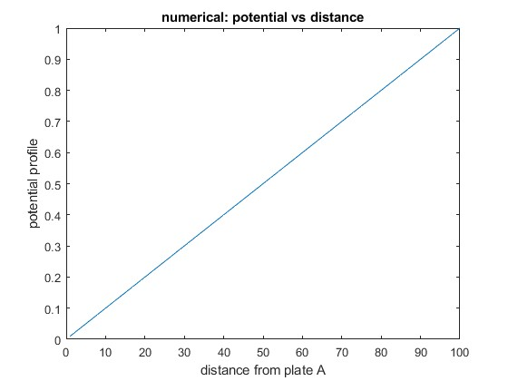

Comparision:

clc;

clear all;

close all;

response =[];

iter = [];

% analytical

for i=1:100

v=i/100;

response = [response v];

iter = [iter i];

end

%plot(iter, response);

% numerical

for i=1:100

H(i,i)=-2;

end

for i=1:99

H(i+1,i)=1;

end

for i=1:99

H(i,i+1)=1;

end

A=zeros(100,1);

A(100,1)=-1;

v=(inv(H)*A);

i=1:100;

plot (iter, response, i, v);

xlabel('distance from plate A');

ylabel('potential profile');

title('comparisaton numerical and analytical: potential vs distance');

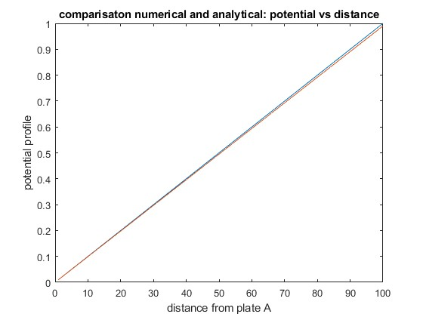

Q.2:- For the same configuration as above, assume both plates are grounded, and a

charge sheet of zero thickness but with charge of 10-6C/cm2

is placed at a distance of

30mm from plate A towards plate B. Find the potential profile from Plate A to Plate B.

Obtain the results using the analytical methods as well as numerical methods. Compare

the results obtained using both the methods.

Ans:

Analytical:

clc;

clear all;

close all;

% response1 =[];

% iter1 = [];

% response2 =[];

% iter2 = [];

% sigma=10^(-2);

% dx=0.1/99;

% epsilon=8.85*(10)^(-12);

%analytical

x1=0:0.01:0.03;

f1=0.819*(10^9)*x1;

x2=0.03:0.01:0.1;

f2=-(0.351)*(10^9)*(x2-0.1);

plot(x1,f1,x2,f2);

%numerical

% for i=1:100

% H(i,i)=-2;

% end

% for i=1:99

% H(i+1,i)=1;

% end

% for i=1:99

% H(i,i+1)=1;

% end

% A=zeros(100,1);

% A(30,1)=-((sigma*dx)/epsilon);

% v=(inv(H)*A);

% plot (v);

xlabel('distance from plate A');

ylabel('potential profile');

title(' analytical: potential vs distance');

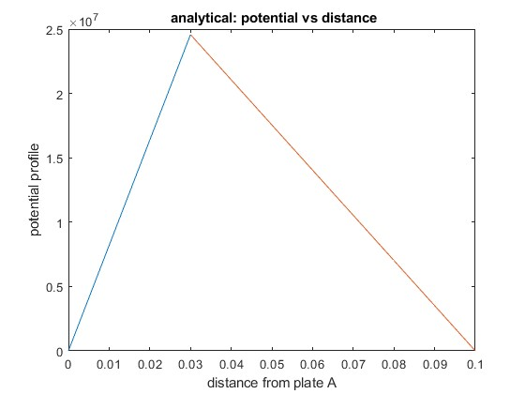

Numerical:

clc;

clear all;

close all;

response1 =[];

iter1 = [];

response2 =[];

iter2 = [];

sigma=10^(-2);

dx=0.1/99;

epsilon=8.85*(10)^(-12);

%analytical

% x1=0:0.01:0.03;

% f1=0.819*(10^9)*x1;

% x2=0.03:0.01:0.1;

% f2=-(0.351)*(10^9)*(x2-0.1);

%plot(x1,f1,x2,f2);

%numerical

for i=1:100

H(i,i)=-2;

end

for i=1:99

H(i+1,i)=1;

end

for i=1:99

H(i,i+1)=1;

end

A=zeros(100,1);

A(30,1)=-((sigma*dx)/epsilon);

v=(inv(H)*A);

plot (v);

xlabel('distance from plate A');

ylabel('potential profile');

title(' numerical: potential vs distance');

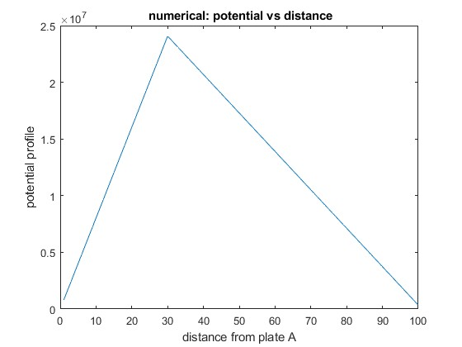

Comaparisation:

clc;

clear all;

close all;

response1 =[];

iter1 = [];

response2 =[];

iter2 = [];

sigma=10^(-2);

dx=0.1/99;

epsilon=8.85*(10)^(-12);

%analytical

x1=0:0.01:0.03;

f1=0.819*(10^9)*x1;

x2=0.03:0.01:0.1;

f2=-(0.351)*(10^9)*(x2-0.1);

%plot(x1,f1,x2,f2);

%numerical

for i=1:100

H(i,i)=-2;

end

for i=1:99

H(i+1,i)=1;

end

for i=1:99

H(i,i+1)=1;

end

A=zeros(100,1);

A(30,1)=-((sigma*dx)/epsilon);

v=(inv(H)*A);

i=1:100;

plot (x1,f1,x2,f2,i,v);

xlabel('distance from plate A');

ylabel('potential profile');

title(' comparision analytical and numerical: potential vs distance');

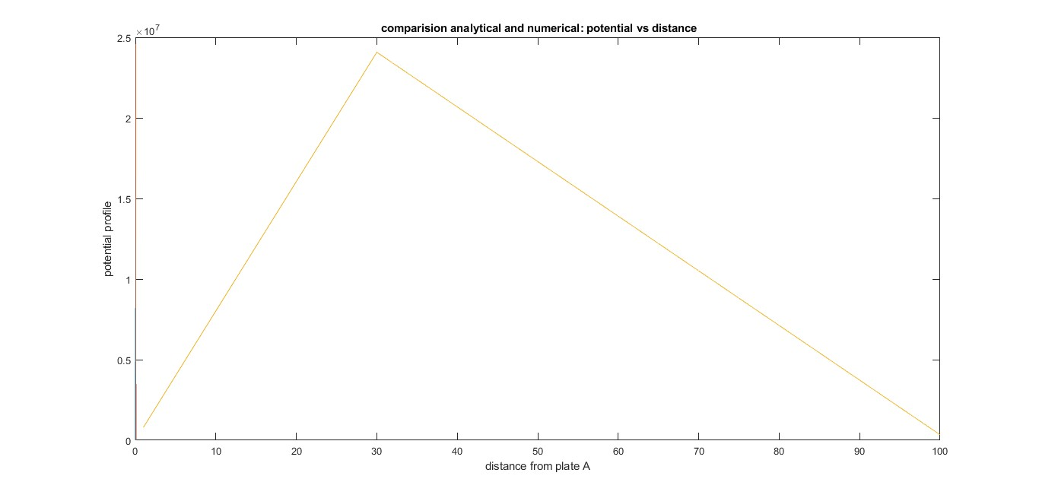

Q.3:- For the problem (1), assume that the dielectric constant varies as a function of

spatial co-ordinates as follows:

εr=1,0<x<30mm

εr=3,30<x<100mm

Find the potential profile from Plate A to Plate B and compare it with that of case (1).

Obtain the results using the analytical methods as well as numerical methods. Compare

the results obtained using both the methods.

ANS

Analytical:

clc;

clear all;

close all;

response1 =[];

iter1 = [];

response2 =[];

iter2 = [];

sigma=10^(-2);

dx=0.1/99;

epsilon=8.85*(10)^(-12);

epsilon1=1;

epsilon2=3;

%analytical

x1=0:1:30;

f1=(0.01875.*x1);

x2=30:1:100;

f2=((0.00625.*x2)+0.375);

plot(x1,f1, x2, f2);

%numerical

% for i=1:100

% H(i,i)=-2;

% end

% for i=1:99

% H(i+1,i)=1;

% end

% for i=1:99

% H(i,i+1)=1;

% end

% H(30,29)=epsilon1*epsilon;

% H(30,30)=-(epsilon1+epsilon2)*epsilon;

% H(30,31)=epsilon2*epsilon;

% A=zeros(100,1);

% A(100,1)=-1;

% v=inv(H)*A;

% plot (v);

xlabel('distance from plate A');

ylabel('potential profile');

title('analytical: potential vs distance');

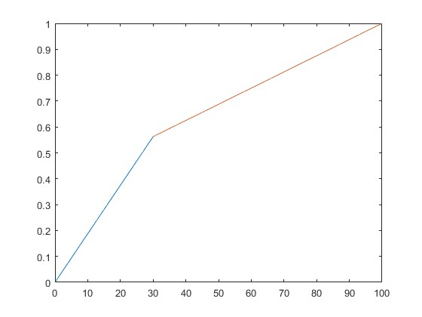

Numerical:

clc;

clear all;

close all;

response1 =[];

iter1 = [];

response2 =[];

iter2 = [];

sigma=10^(-2);

dx=0.1/99;

epsilon=8.85*(10)^(-12);

epsilon1=1;

epsilon2=3;

%analytical

% x1=0:1:30;

% f1=(0.01875.*x1);

% x2=30:1:100;

% f2=((0.00625.*x2)+0.375);

% plot(x1,f1, x2, f2);

%numerical

for i=1:100

H(i,i)=-2;

end

for i=1:99

H(i+1,i)=1;

end

for i=1:99

H(i,i+1)=1;

end

H(30,29)=epsilon1*epsilon;

H(30,30)=-(epsilon1+epsilon2)*epsilon;

H(30,31)=epsilon2*epsilon;

A=zeros(100,1);

A(100,1)=-1;

v=inv(H)*A;

plot (v);

xlabel('distance from plate A');

ylabel('potential profile');

title('numerical: potential vs distance');

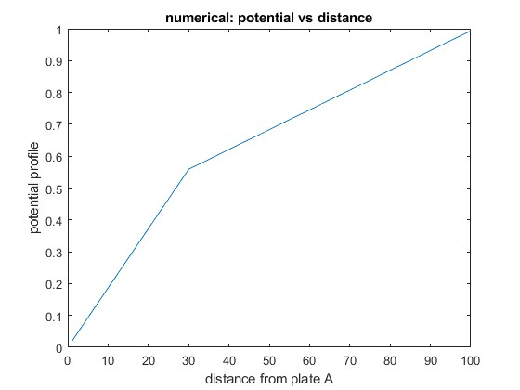

COMPARISION:

clc;

clear all;

close all;

response1 =[];

iter1 = [];

response2 =[];

iter2 = [];

sigma=10^(-2);

dx=0.1/99;

epsilon=8.85*(10)^(-12);

epsilon1=1;

epsilon2=3;

%analytical

x1=0:1:30;

f1=(0.01875.*x1);

x2=30:1:100;

f2=((0.00625.*x2)+0.375);

% plot(x1,f1, x2, f2);

%numerical

for i=1:100

H(i,i)=-2;

end

for i=1:99

H(i+1,i)=1;

end

for i=1:99

H(i,i+1)=1;

end

H(30,29)=epsilon1*epsilon;

H(30,30)=-(epsilon1+epsilon2)*epsilon;

H(30,31)=epsilon2*epsilon;

A=zeros(100,1);

A(100,1)=-1;

v=inv(H)*A;

plot (x1,f1, x2, f2,i,v);

xlabel('distance from plate A');

ylabel('potential profile');

title('numerical: potential vs distance');

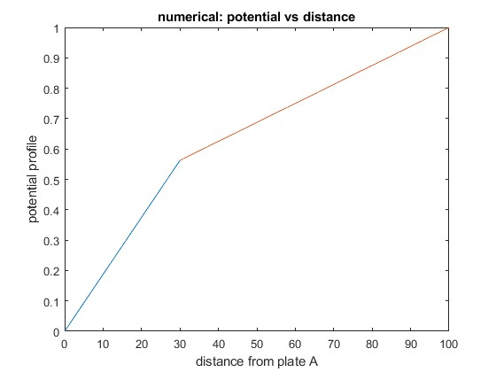

Q.4:- Assuming the conditions in case (1), assume that the region between A and B has

a charge density of q×1016 cm-3, where q is the electronic charge. Find the potential

profile between the plates A and B. Obtain the results using the analytical methods as

well as numerical methods. Compare the results obtained using both the methods.

Ans

Numerical and analytical and comparisation:

n = input("enter the value of points for discretization");

w = 100;

M = [];

C = [];

V = [];

y = [];

k = (1.6)/8.85;

x = 0:1:100;

y = (-k/2)*x.^2 + (50*k + .01)*x;

for i=1:n

for j=1:n

if j==i

M(i,j) = -2;

elseif j==i-1 || j==i+1

M(i,j) = 1;

else

M(i,j)=0;

end

if i == n

C(i) = -1;

else

C(i) =-1*k ;

end

end

end

tr_c = transpose(C);

inv_M = inv(M);

V = inv_M*tr_c;

subplot(2,1,1)

plot(1:n,V)

xlabel('x')

ylabel('Voltage')

title('Voltage Profile using numerical method')

subplot(2,1,2)

plot(x,y)

xlabel('x')

ylabel('Voltage')

title('Voltage Profile Using Analytical method')

